Sun Devil Braking Co.
Phase 2 Report: Car Braking System
John Garcia, Ryan Mokdad, Sergio Cardenas, Zuheir Jabbar, Raphael Soto, Jackson Letsinger
February 2, 2026
Introduction:
Sun Devil Braking Co. is a newly founded company that is working on creating efficient and reliable braking systems for general automobiles. This report will cover the second phase of the design, development, and testing of the team's braking system design, including a full 3D CAD model of the brake system and its components. The following model was developed in Solidworks and then analyzed using Ansys. To evaluate the structural and thermal performance of the system, analyses were performed specifically on the brake rotor, including transient structural analyses, transient thermal analyses, and static structural analyses. Building on failure modes discussed in phase one, these analyses will serve to validate critical design choices such as material and/or geometric tolerances. Additional design choices were made taking into account 3D printing capabilities and constraints. Altogether the CAD model and results from these analyses indicate that the rotor remains safe under assumed conservative loads and deformation limits, and the brake system will be ready for prototyping and physical testing in phase three.

Overview of Final Design:
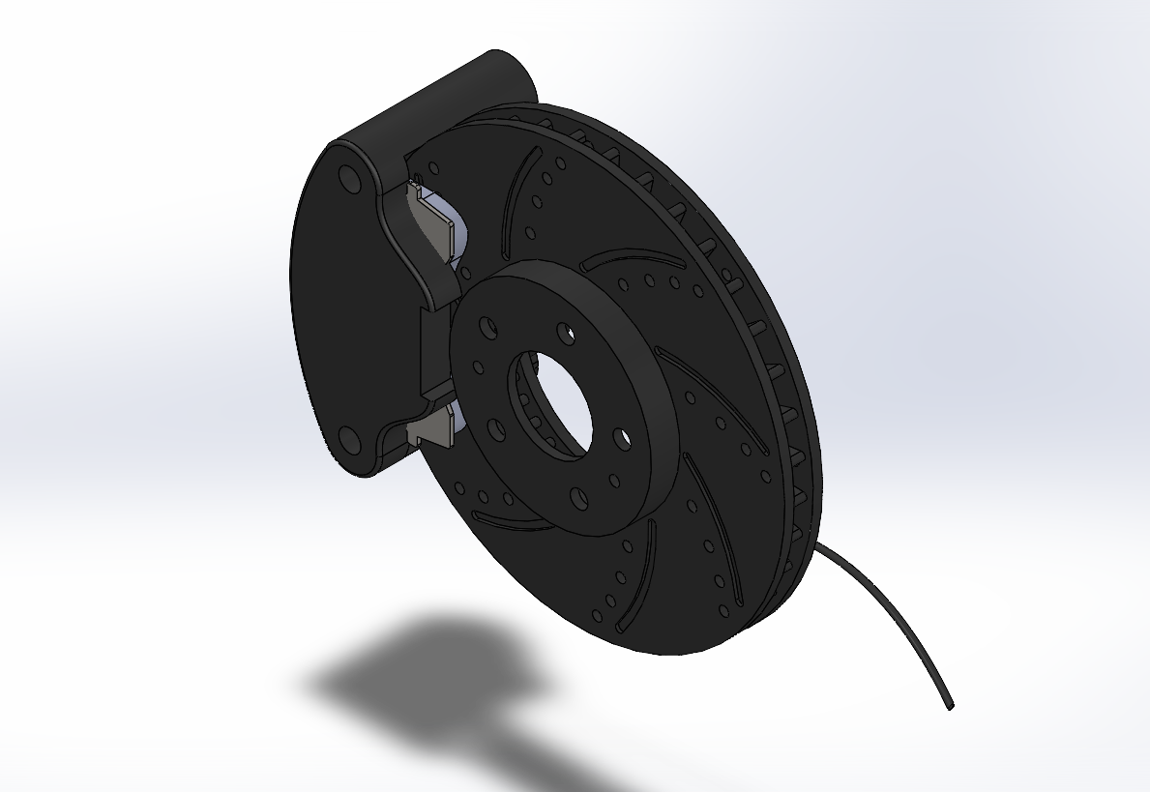
Fig 1.1 - Full braking system CAD model
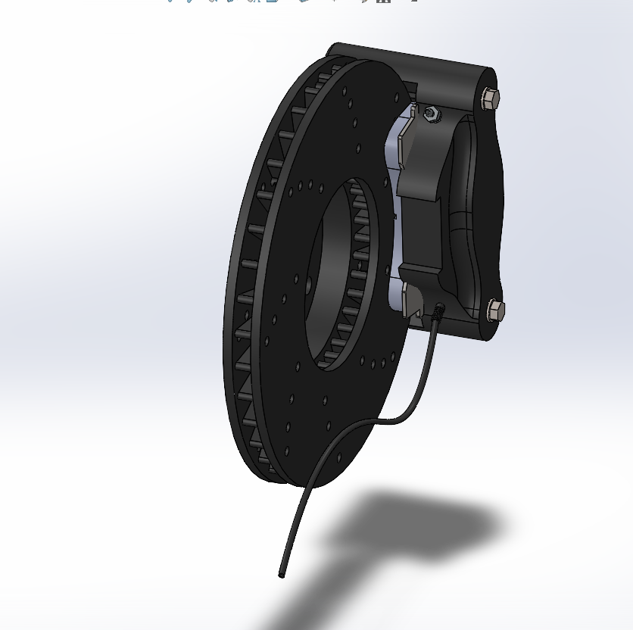
Fig 1.2 - Full braking system CAD model, second angle
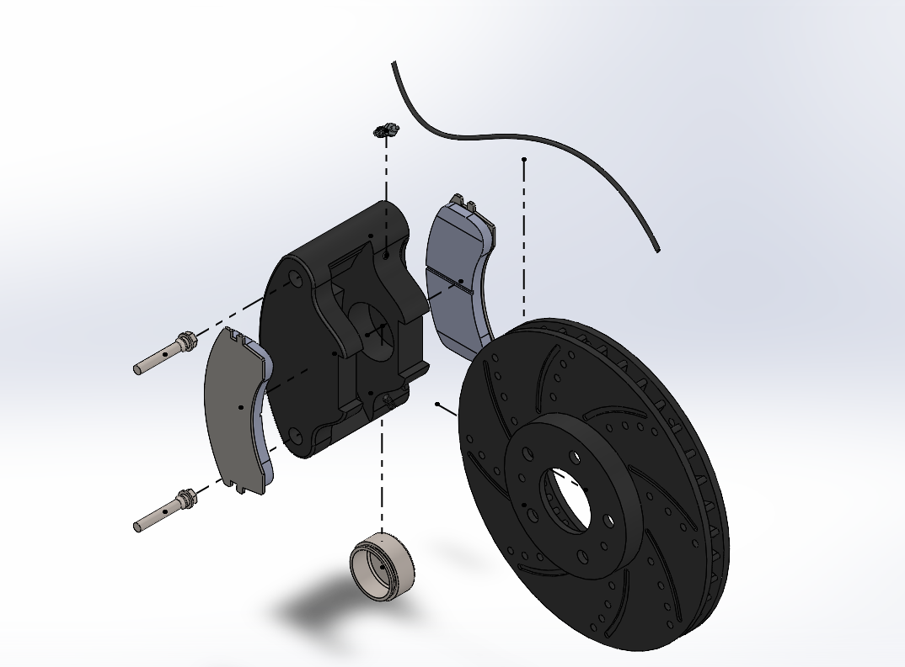
Fig 1.3 - Exploded view of full braking system CAD model

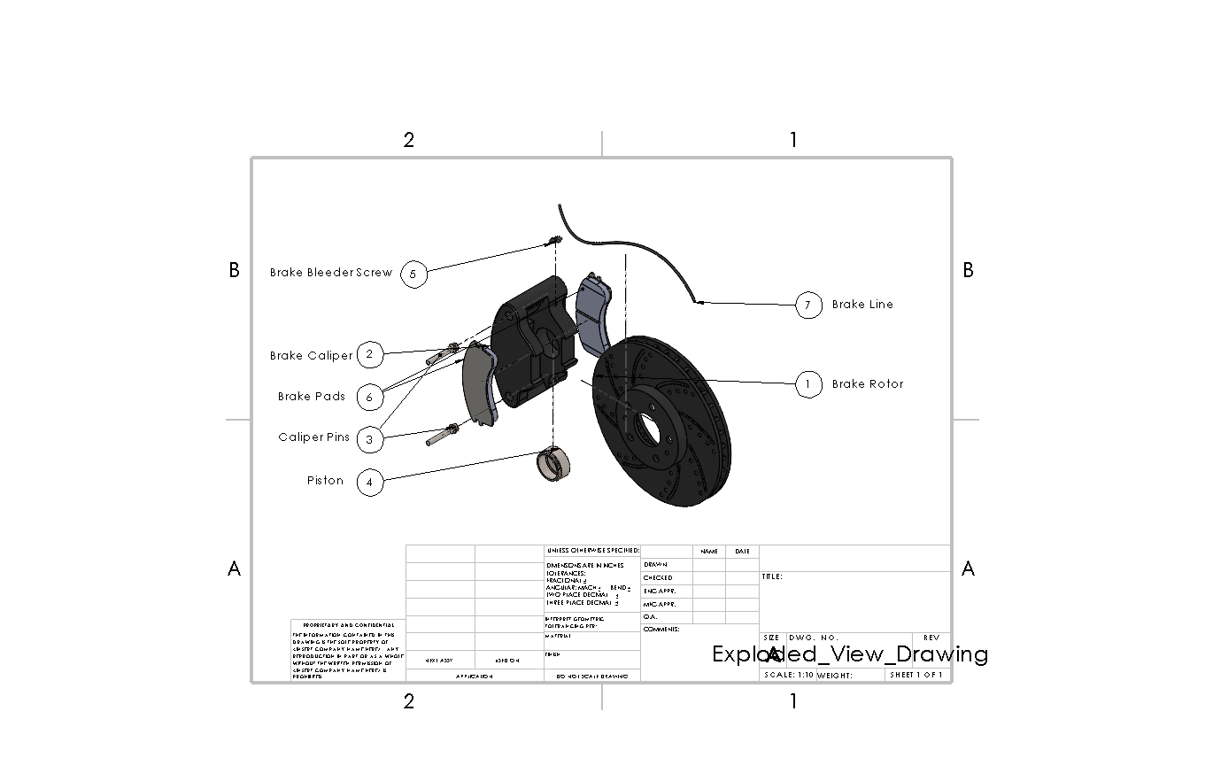
Fig 1.4 - Exploded labeled drawing of the full braking system CAD model
Here is the exploded CAD view of the braking system. All the parts were made from scratch in SolidWorks and sized to each other so that all the components could be put together to make the full braking system as seen above.
Major Decision Decisions and Changes:
In phase 1 of this project, the general plan was to build a braking system for a basic everyday car. The intention was to do a full system Ansys analysis, but after thorough thought, it was reasoned out that the only component in the system that needed in-depth analysis was the brake rotor, as it undergoes the most stress concentration, mechanical loading, and direct wear during the operation of braking. The rotor is exposed to frictional forces from the brake pads, torsional loading from the braking torque, and shear stress distributed across its cross-section, which makes it much more reasonable for running tests specifically on it compared to each individual component of the whole braking system. All the other components are not necessary to run ANSYS analysis on, as their main failure mechanisms are from aging and standard wear. This will be covered more in the analysis section, but this was a major decision that the team made since the first phase of this project. Being that brake rotors usually fail over time and not during a static scenario, majority of the test and analysis that were ran, were done for a transient scenario over a set time of 10 seconds. There were still static structural test ran, but the team made the decision that transient analyses would reveal more about the system operation.
Analysis Considerations/Assumptions:
- Braking varies car by car and differentiates based on the driver of the vehicle and how intensely and often the brakes are used. The intensity of braking is the main cause of how brake calipers and brake systems deteriorate over time, and causes them to break.
- These analyses that were performed took conservative approaches, such as using average researched pressures, speeds, and temperatures.
- Typical brake fluid pressure is 800 psi to 1500 psi for a standard car, so we took a conservative approach and assumed a pressure of 1000 psi.
- The rotor material was chosen as a gray cast iron and was kept this material for all the analysis ran.
- The gray cast iron was properties were found from a materials table and referenced multiple times in the interpretation of the results
Required Analyses:
After considering how a real braking system works in a basic vehicle, it was determined that the major Ansys analysis should be run on the brake rotor rather than all of the parts individually. The majority of the parts only fail due to wear and tear and aging. The brake rotor, on the other hand, as discussed above, experiences frictional forces, torsional loading, and shear stress, which makes it the key component that needs to be analyzed in a braking system as it is the most likely to fail. The three main tests that need to be run on the brake rotor are a transient structural analysis, a transient thermal analysis, and a static structural analysis. The team ran a variety of these analyses, including combining some of these into one analysis.
The typical pressure in brake fluid is 800-1500 psi, so we made a steady assumption and used 1000 psi, which is equal to 6.895 MPa. From this, the pressure on the rotor was able to be found using equations from the first phase of this project.
$F_{piston}=P_{brake fluid}⋅\frac{π{D_{piston}}^{2}}{4}$
$F_{piston}=6.895 *10^{6} ⋅\frac{π{(60.45/1000)}^{2}}{4}$
$F_{piston}= 19785.81 N$
$P_{rotor}=F_{piston}/A_{brake pad}$
$A_{brake pad}=7861.16+1565.9+128.01$ *From Solidworks brake pad area
$P_{rotor}=(19785.81/(7861.16+1565.9+128.01)*10^{6}$
$P_{rotor}=2.07MPa$
This calculated pressure is what was used in the analysis that was performed on the brake rotor as the applied pressure force.

Static Structural Analyses
The static structural analysis is aimed at evaluating the rotor's ability to withstand and hold during max braking loads without failing. This analysis assumes a constant load, and from this, the maximum stress within the rotor can be determined along with the overall factor of safety. The importance of this analysis is that the rotor must be able to resist the max applied torque during the process of braking, as the peak load condition represents the worst possible case for structural failure. The static structural analysis was done in Ansys by applying a pressure of 2.07 MPa at both sides of the rotor over the area of the brake pad, a fixed support at the inside face of the brake rotor, and a rotational velocity load of 55 rad/s about the z-axis. The key results from this analysis were the directional deformation along the z-axis, the equivalent stress, and the factor of safety.
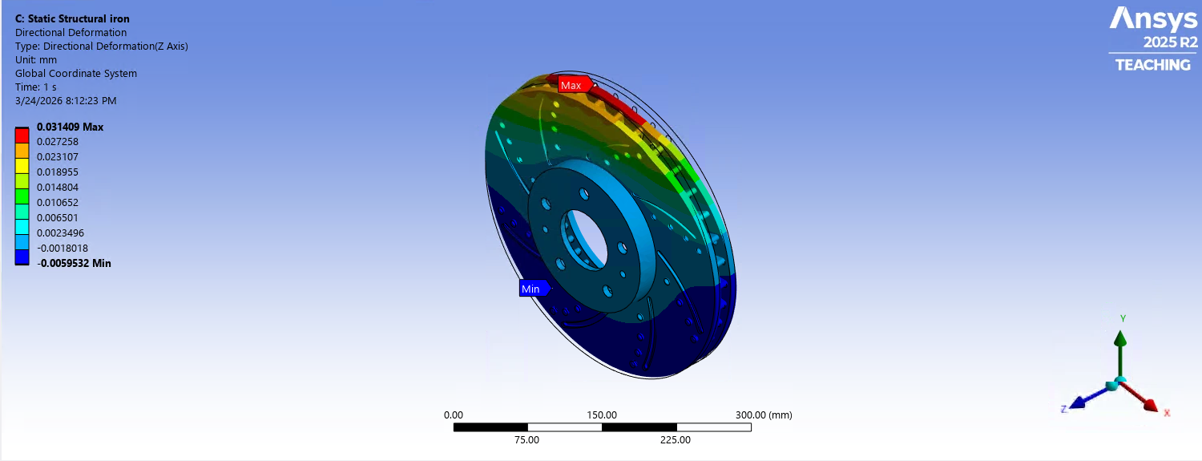
Fig 1.5 - Static structural directional deformation in the Z axis results

A pressure force was applied on both sides of the rotor for an area that is equal to the size of bad pads. During braking, brake pads are applied on both sides of the rotor and use friction with the rotor to initiate the process of braking where kinetic energy is converted into thermal energy. For all of these tests an area was created on the rotor that was equal to the size of the brake pads and this area was where the pressure was applied that came from the brake pads. This pressure was calculated above and was applied for all the Ansys analysis. These results show the static structural analysis done on the brake rotor, specifically the directional deformation that is caused from the pressure from the brake pads. It can be seen that the max deformation was 0.031409 mm which is in a safe range and shows the rotor is behaving as a stiff part which is expected. This simulated in a static structural case the brake pad applying pressure on the rotor, and shows that the rotor resisted the pad force without significant bending, maintained alignment with the caliper, and avoided vibration or uneven contact. Therefore this analysis determined that the rotor is safe in a static structural deformation case.
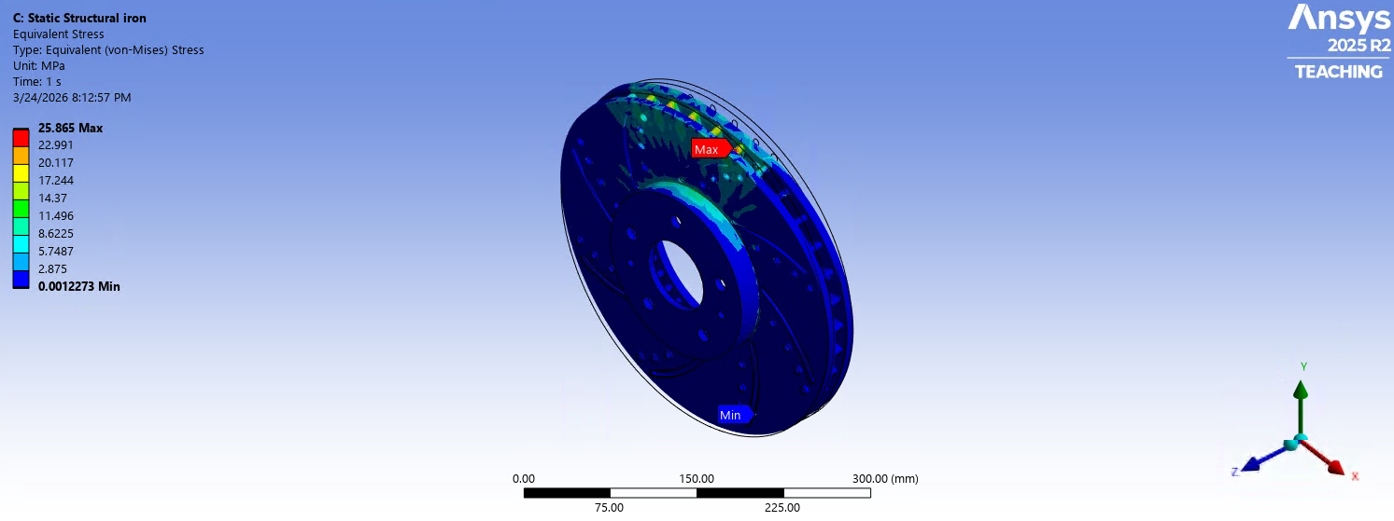
Fig 1.6 - Static structural equivalent Von-Mises stress results

Here, the same pressure was applied on the rotor, but the results now show the equivalent stress. The results show that max value of stress occurs when braking and occurs in the region of where the brake pads are applied. A max stress of 25.865 MPa is generally not high for a real rotor made of gray cast iron. From material properties, typical tensile strength for the material is up to 450 MPa and typical elastic limit is up to 293 MPa and our results are much lower than this which indicates that the rotor is not close to static failure under this load. This shows that the rotor could take harsher braking pressures which is expected as this is just an average estimation of the pressure from braking.

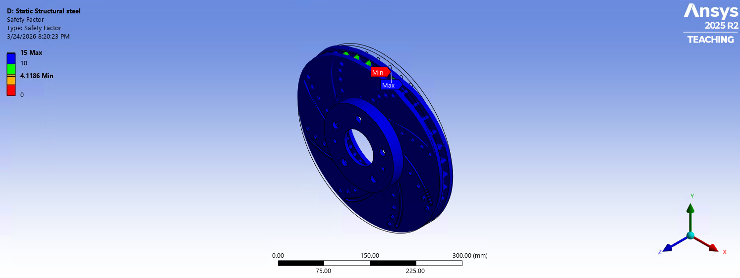
Fig 1.7 - static structural safety factor results
To find the safety factor of the rotor, a fatigue analysis was performed in Ansys using the Goodman Mean Stress theory, a zero-based loading type, a fatigue strength factor of 0.7, and a design life of 10 million cycles. Here is the factor of safety results on the brake rotor from the fatigue analysis. This means that theoretically the rotor can withstand about 4.12 times the applied load before reaching the failure criteria that was used in the Ansys analysis. Further this shows that the rotor is not close to static failure and has a healthy safety margin under the modeled conditions, therefore confirming the rotor is physically safe. The limitation to these static structural analyses is that they don’t represent performance under repeated braking cycles, and thermal expansion and fatigue.

Transient structural Analysis
Although a basic static structural analysis shows a good idea of how the rotor will behave under a constant pressure from the brake pads, applying a transient structural analysis will help accurately understand how the rotor will behave with progressively increasing applied pressure. The transient structural analysis aims to analyze how the rotor responds to time-varying loads during braking, which is important because this captures the realistic operation conditions. A braking system is a time-dependent process, as the driver increases and decreases the force applied to the brake over time. This analysis takes into account the changes in force over time, dynamic effects such as acceleration and deceleration, and the stress fluctuations caused by the engagement and release of the brake. The importance of this analysis is that it shows how stress builds up on the rotor over time, the role of dynamic loading, and the potential for fatigue and risks associated with cyclic loading. The transient structural analysis was done in Ansys by applying an increasing pressure from 0MPa to 2.07 MPa at both sides of the rotor over the area of the brake pad, a fixed support at the inside face of the rotor, and a rotational velocity load of 55 rad/s about the z-axis. The key results from this analysis were the directional deformation along the z-axis and the equivalent stress across each value of pressure.

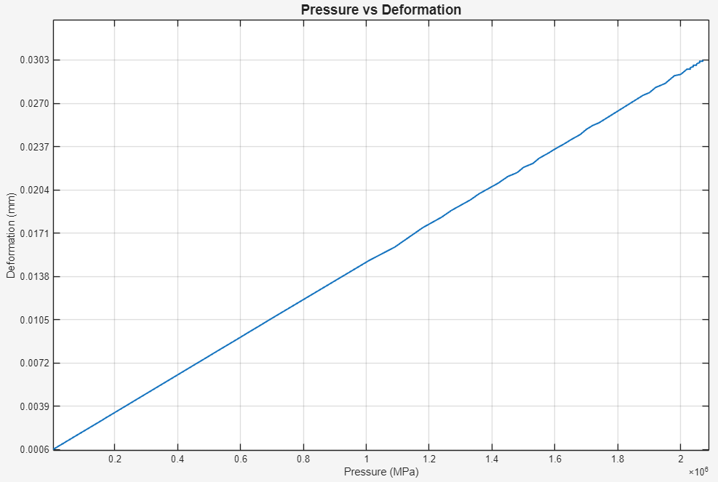
Fig 1.8 - Pressure vs Deformation graph along the Z axis for pressure of 0 MPa to 2.07 MPa.
For this analysis there was a constant temperature and speed with a change in pressure from 0 to 2.07 MPa over the area of the brake rotor. It can be seen that as the pressure increases, the deformation increases almost linearly. This relationship could be used to find the max braking pressure that could be applied until the deformation reaches a point of failure.

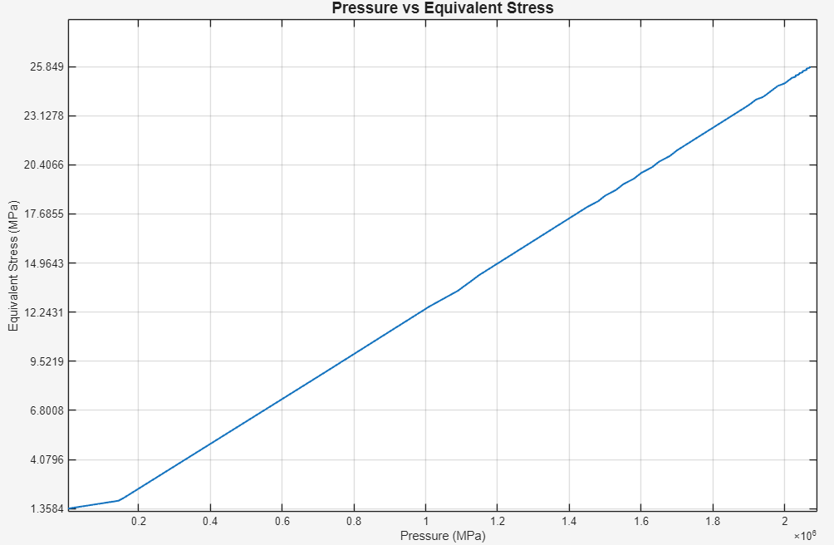
Fig 1.9 - Pressure vs Equivalent Stress graph for pressure of 0 MPa to 2.07 MPa.
For this analysis there was a constant temperature and speed with a change in pressure from 0 to 2.07 MPa over the area of the brake rotor. Once again, as the pressure increases, it can be seen that the equivalent stress also increases showing a linear relationship. This could also be used to see at what pressure the equivalent stress reaches a point where the material would fail.

Transient Thermal Analysis
The transient thermal analysis aims to evaluate the heat that is generated on the rotor and the distribution of temperature in the rotor over time. In the process of braking, kinetic energy is converted into thermal energy through the friction with the brake pad. This analysis is important as high temperatures can reduce the strength of the rotor material, uneven heating can cause warping and thermal expansion, brake fade, and long-lasting damage is primarily caused by thermal effects. A transient thermal analysis allows the team to analyze how and where heat builds up during braking, the temperature distribution across the rotor, and the cooling behavior after braking. The thermal transient analysis was done in Ansys by applying an increasing temperature value from 35°C to 220°C over 10 seconds with a 0.1-second unit step to the rotor, and a convection coefficient of 5 W/m^2 with an ambient temperature of 35°C. The key result from the transient thermal analysis was the total heat flux at the temperature range of 35°C to 220°C. A coupled thermal-structural analysis was performed to help accurately understand how the brake rotor behaves with heat flux generation from friction. This was completed in Ansys by applying a static structural analysis to the initial transient thermal analysis. The key results from this analysis were the directional deformation along the z-axis and the equivalent stress at 220°C, as well as the deformation across increasing temperature values.
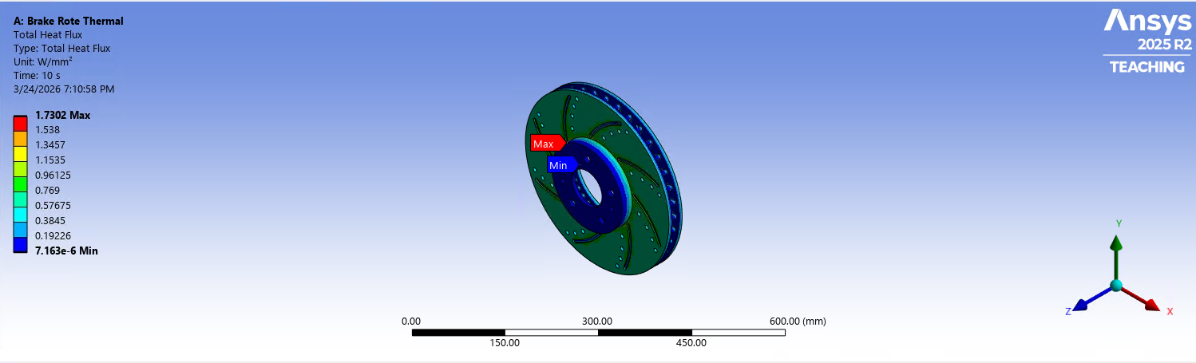
Fig 2.0 - Total Heat flux at 220° Celsius results
Here are the results for the total heat flux where the temperature starts at 35°C increasing to 220°C over a 10 second period. The max heat flux was 1.7302 $W/mm^{2}$ which means the hottest area of the rotor is transferring heat at a rate of 1.7302 Joules per second per millimeter squared. This is a fairly intense heat transfer rate but makes sense as braking is concentrated at this zone where the brake pads and the rotor make contact. From this it can be justified that the rotor is absorbing and moving heat away from the contact region, the heating is concentrated in a localized hot spot, and the rotor is experiencing real thermal loading rather than uniform heating. This by itself does not tell whether the rotor is safe, but very steep temperature differences, excessive deformation, or stresses high enough to cause cracking or warping would be indicators of failure.

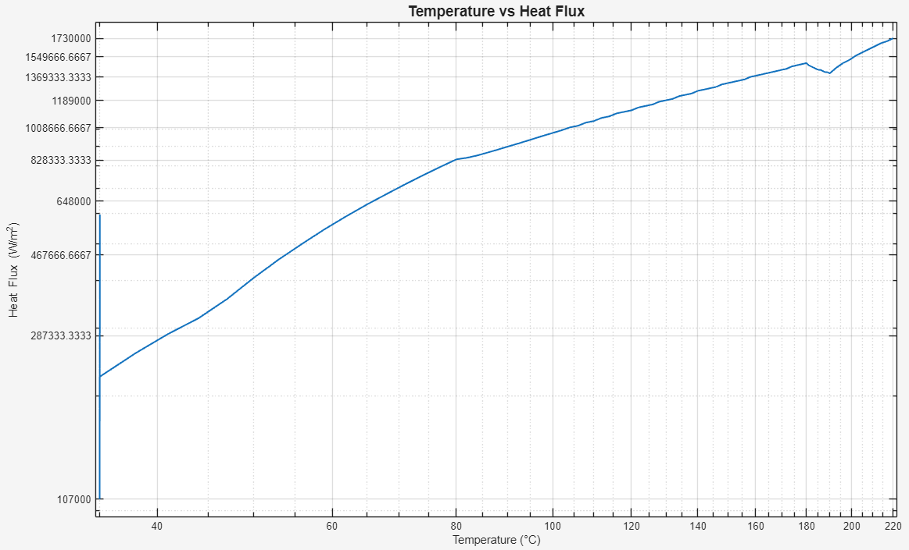
Fig 2.1 - Temperature vs Heat Flux Log-Scale graph.
For this analysis there was a changing temperature from 35°C increasing to 220°C with a constant convection coefficient. No external forces were applied for this analysis. The total heat flux of the rotor greatly increases at the initial temperatures then decreases to a value of 1.41 $W/mm^{2}$. Once the total heat flux reaches this value, it steadily increases until there is a sudden decrease from 1.49 $W/mm^{2}$to 1.4 $W/mm^{2}$ at 180°C. The total heat flux then continues to increase to a value of 1.73 $W/mm^{2}$at 220°C. This increase in heat flux with temperature shows that the rotor is experiencing higher rates of thermal energy transfer as it heats up. A value of the total heat flux that exceeds the limit of gray cast iron could result in failure of the rotor. The total heat flux range for gray cast iron is 1 $W/mm^{2}$ to 10 $W/mm^{2}$, with the current design of the rotor, the total heat flux stays within the lower bounds of this range.
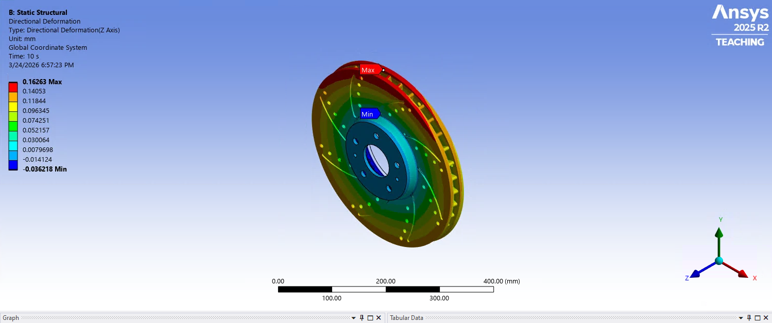
Fig 2.2 - Transient thermal directional deformation in the Z axis results
Here is the directional deformation along the z-axis starting at 35°C and increasing to 220°C over a time of 10 seconds. This means displacement increased by about 0.163 mm as the temperature rose from 35°C to 220°C over 10 seconds. This is basically showing the thermal expansion along the rotor axis and not a major structural bend or collapse. Based on the linear thermal expansion coefficient and the temperature rise, there is enough change to produce a displacement of 0.16263 mm and is a reasonable result for gray cast iron. So besides the numbers making sense, safety is also a big consideration and the deformation is small enough that it does not directly indicate failure or excess distortion. For the concern of warping, it can be said that this result won't directly cause warping, as warping usually comes from uneven heating, constraints on natural expansion, or thermal fatigue, so overall from this analysis the rotor is still considered safe.
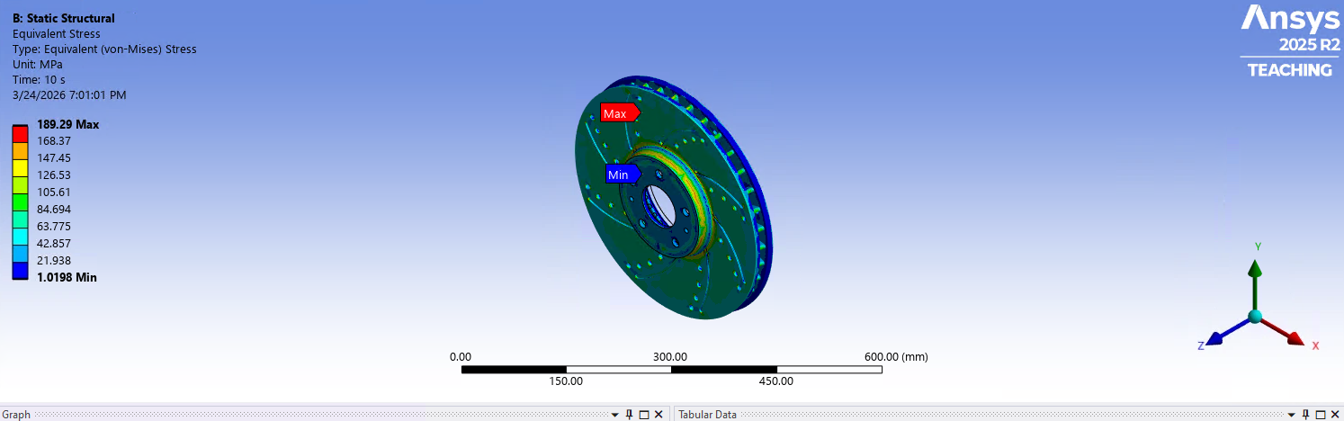
Fig 2.3 - Equivalent Von Mises stress at 220° Celsius Results
Here we ran an equivalent stress transient analysis starting at 35°C and increasing to 220°C over a time of 10 seconds. It can be seen that the max equivalent stress got up to 189.29 MPa which means the highest loaded point in the rotor the combined thermal mechanical stress reached was 189.29 MPa during the 10 second interval. This shows that when braking occurs, real internal stress is acting on the brake rotor which needs to be under a certain limitation so no defects or failures occur. Mentioned before, the max tensile strength of 450 MPa and a max elastic limit of 293 MPa for gray cast iron are limits that we need to stay under, and our max result of 189.29 MPa is well below these limits. It is in a range though, where it is apparent that the brake rotor is realistically responding to heating and expansion during braking. The one concern from this result is from long term thermal fatigue which is something that real brakes experience so it makes sense.

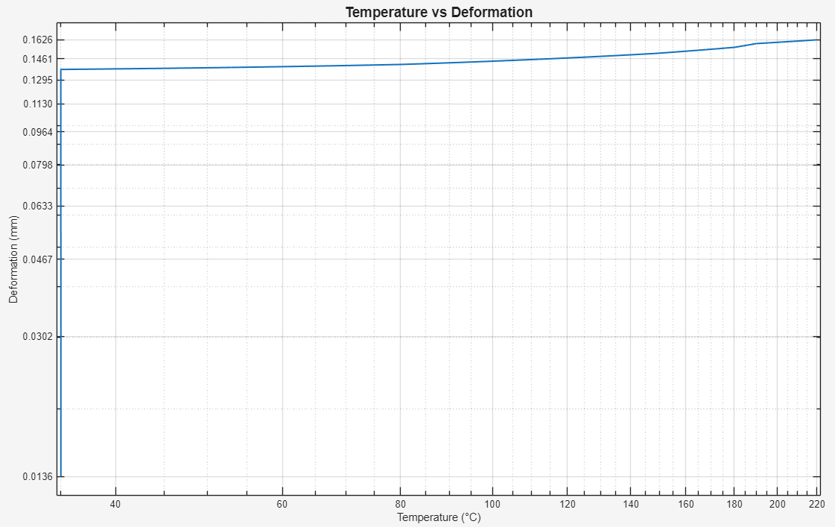
Fig 2.4 - Temperature vs Transient Thermal Deformation along the Z axis Log-Scale graph.
This was done by using a coupled thermal-structural analysis where the temperature changed from 35°C to 220°C while the pressure and speed were constant. From the graph, it can be seen that there is a sudden increase in deformation at the initial temperature values. Once the deformation reaches 0.13612 mm there is only a slight increase until it reaches 0.16263 mm at 220°C. This slight increase in deformation across temperature values could be due to the high stiffness that gray cast iron possesses.

Overall Consensus
From all the analyses that were run on the brake motor, it can be concluded that the brake rotor was built efficiently to perform the way it should in a full scale braking system. The rotor underwent all of the main tests and analyses that would confirm whether the rotor would function as intended without bypassing any critical safety thresholds. All of the tests showed very little concern for the rotors safety and showed whether it would perform under considerable pressures that are applied on it during braking. From this it can be concluded that the analyses prove the rotor is safe, operational, and ready to be put into a full braking system.

3D printing and Assembly Design:
All of the components for the braking system were made in SolidWorks from scratch to be able to build a full design at a small prototype scale. Each part was made so that it could be properly aligned and positioned into a full braking system with ease, and leave room for easy iterations and changes. The assembly is straightforward when compared to standard braking systems in the average American car and is easily repeatable.

- Brake Rotor: A disk made of gray cast iron spinning in conjunction with the car wheel. Slows the vehicle by converting its rotational kinetic energy into heat through friction when in contact with the brake pads. Has internal vanes, slots, and drilled holes to increase surface area and airflow to maximize air cooling.
- Brake Caliper: A structural assembly containing the piston and brake pads, which uses the pressure of the brake fluid created within the brake lines to compress the piston.
- Caliper pins: Lubricated sliding pins used to smoothly align the brake pads and rotor as the pads are applied.
- Piston: 60.45 mm diameter piston made of 316 stainless steel to withstand the high pressures of the brake fluid while offering corrosion resistance to the brake fluid. The large piston diameter allows the piston to convert the pressure from the brake lines to a large force acting on the brake pads.
- Brake Bleeder Screw: Used to drain brake fluid or bleed air from the brake lines. Located at the top end of the caliper prevent air from being trapped within the system. Uses a standard 11mm wrench head.
- Brake Pads: Plates of friction material are compressed against the brake rotor to slow the vehicle by creating a torque against the rotor. The friction material of the pads varies from metallic, ceramic, to less commonly organic materials. Designed to function as the depth of the material is worn down over time, and ultimately be replaced.
- Brake Line: Tube made of EPDM (Ethylene Propylene Diene Monomer) used to translate the pressure of the brake fluid from the brake master cylinder to the piston. The material allows it to withstand high pressures and temperatures, while simultaneously offering flexibility, necessary for situations such as when the wheel is turning.

Anticipated Risks and Weaknesses in Prototyping:
- Limitations in physical testing - The full system performance and true dynamics of a braking system can’t be fully tested, as this is just a model and doesn’t have the full performance capability of a real car braking system.
- Material Limitations – The 3D printing and assembly of the design will be made out of a 3D print material (ABS, PLA, etc.)that has low strength, poor heat and friction resistance, and cannot withstand high stress like the materials of real-life braking systems. Also, the brake lines, which are essentially tubes, can’t be 3D printed, so an alternate material will have to be chosen.
- Thermal Effects Not Accurately Modeled – Real braking systems generate a lot of heat over time from converting the kinetic energy into dissipated heat. A physical model can't capture this because there is no kinetic energy that would be applied, which would generate no heat/thermal effects. This can be modeled more accurately in ANSYS, which is a test that will be performed.
- Wear Not Captured in Analysis – In the Ansys analysis and in the prototype model, the wear on the braking system, specifically on the brake rotor and pads, is not captured. Realistically, the brake rotor and pads would degrade over time, but this goes unconsidered in analysis.
- Manufacturing Tolerances – When 3D printing all of the individual parts, there may be inaccuracies and imperfections in the components from printing. This may affect alignment and the function of the braking system.
- Support structures when 3D – For mostly all of the component parts of the braking system that are 3D printed, they require support structures so that the 3D printing machine can properly print the part without any defects. These structures could be hard to remove and cause imperfections/defects in the process of removing them.

References
Luo, Q., Shen, J., Wang, X., Farmilo, N., & Guo, X. (2024). Microstructure evolution and tribo-oxidation induced by friction and wear of cast iron brake discs. Surface Science and Technology, 2(1). https://doi.org/10.1007/s44251-023-00031-4
Properties: An Introduction to Grey Iron. (2019). AZoM.com. https://www.azom.com/properties.aspx?ArticleID=783
SAE International Recommended Practice, BRAKE SYSTEM RATING TEST CODE–COMMERCIAL VEHICLES, SAE Standard J880_198002, Revised February 1980, https://doi.org/10.4271/J880_198002. (justification for 2 MPa force on rotor)
Silva, S. A. M. D., & Kallon, D. V. V. (2019). FEA on different disc brake rotors. Procedia Manufacturing, 35, 181–186. https://doi.org/10.1016/j.promfg.2019.05.025

